**Introduction**

This lab experience involves Amazon Web Services (AWS), and you will use the AWS Management Console to complete all the lab steps.

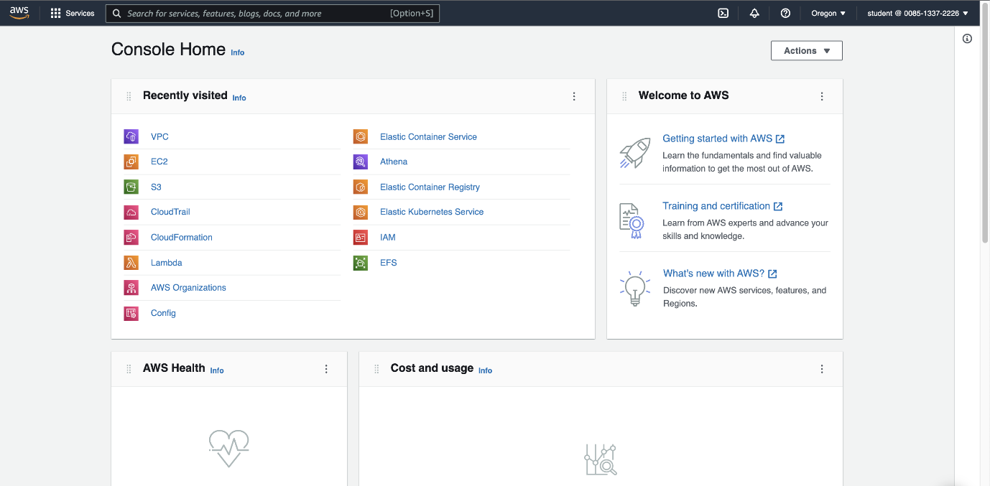

The AWS Management Console is a web control panel for managing all your AWS resources, from EC2 instances to SNS topics. The console enables cloud management for all aspects of the AWS account, including managing security credentials and even setting up new IAM Users.

**Instructions**

1. To start the lab experience, open the Amazon Console by clicking the **Open Environment** button in the upper-left corner of the lab:

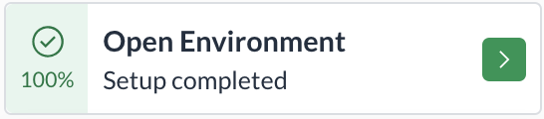

You will see **100% Setup completed** status once the lab environment resources are created.

2. Enter the following credentials created just for your lab session, and click **Sign in**:

* **Account ID or alias**: *045166739694*
* **IAM user name**: *student*
* **Password**: *Ca1_mMYJU75d*

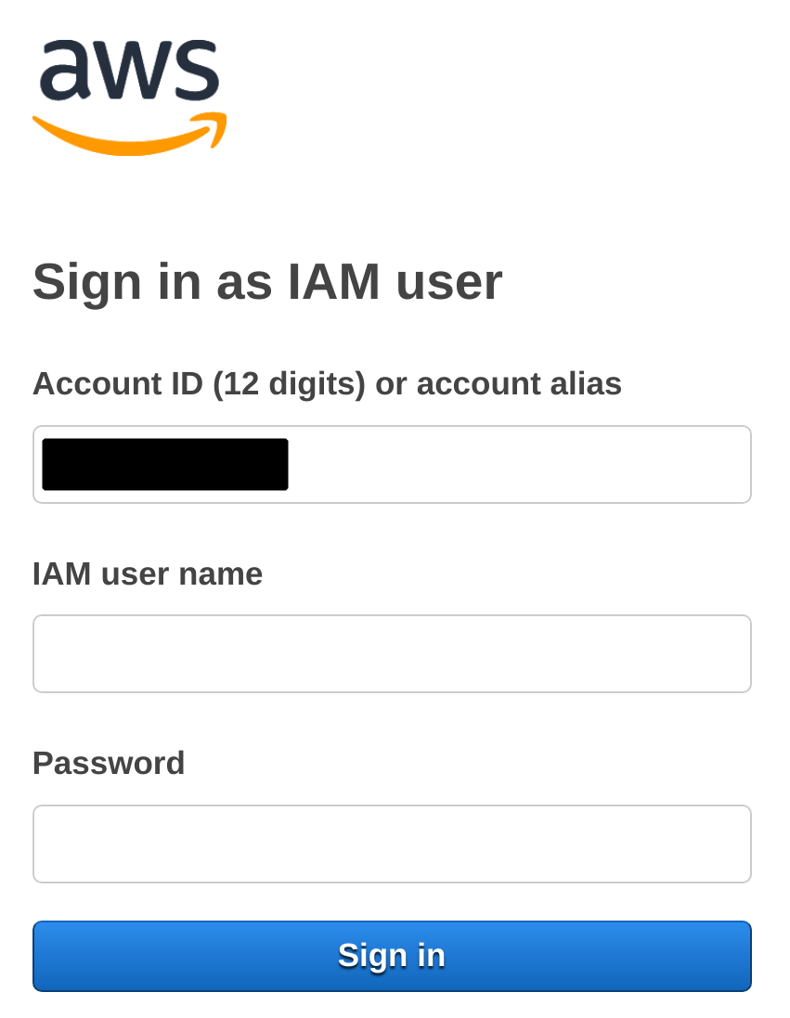

3. Select the **US West (Oregon) us-west-2** region using the upper-right drop-down menu on the AWS Management Console:

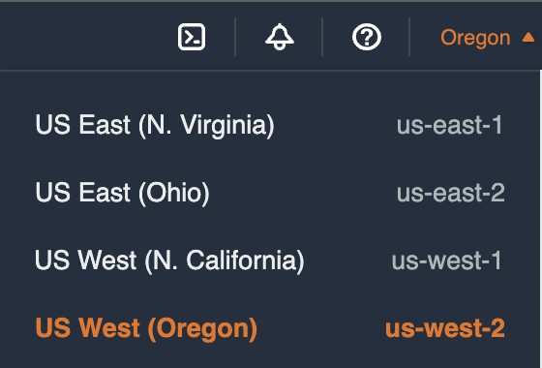

Amazon Web Services is available in different regions all over the world, and the console lets you provision resources across multiple regions. You usually choose a region that best suits your business needs to optimize your customer’s experience, but you must use the **US West 2**for this Lab.